**Objective**: In week 3, we used MariaDB locally on the Raspberry Pi to collect sensor data. Azure has a SQL database service on the cloud as well. We are going to re-build the database with Azure and visualize it using PowerBI. (The IoT hub’s name will show ‘testnumber2-hub’ start from this week, but I’m going to stick with ‘testnumber1-hub’ in the tutorial)

**Required Setup**: Week 5 lab and Azure set-up from previous weeks.

**Parts:**

* RPi 3 B
* GrovePi+ board
* Two Grove connection wires
* 1 x Grove Temperature and Humidity Sensor
* 1 x Grove LCD RGB Backlight v2.0

**Part 1: Set up a SQL database on Azure**

**Step 1.** Sign into the Azure portal using <https://portal.azure.com/#home>. You should see your dashboard.

**Step 2.** Click on ‘+Create a resource’ in the main navigation menu. In the search box, type ‘SQL database’, find the service and click on ‘Create’ at the bottom.

**Step 3.** For ‘Database name’, you have to pick a name that is globally unique(mine is testdatabase); for ‘Server’, click on ‘Create new’ and a side panel like the image on the right will prompt from the right. Pick your own ‘Server name’, ‘Server admin login’, and ‘Password’. Click on the ‘Select’ at the bottom of the side panel. Leave other fields as they were and click on ‘Review+Create’ at the bottom. Click on ‘Create’.



**Step 4.** Click on ‘go to resource’, you will now see the main dashboard for Azure SQL database.

**Step 5.** In the left navigation menu for the database, find and choose ‘Query editor(preview)’. Put in the password you just used to create the SQL database. Then click ‘OK’.



**Step 6.** You will now see a blank section called ‘Query 1’. Copy paste the following SQL commands into it. Some of you will notice that this is the exact command you used in week 3 to create the table in the local MariaDB.



**Step 7.** Click ‘Run’.

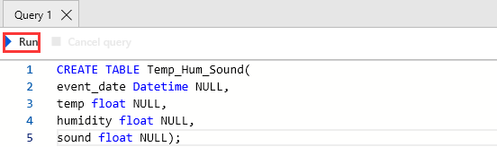

**Step 8.** Click on the ‘Tables’ from the list on the left to check if the table is created successfully.

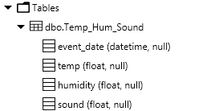

**Step 9.** Now it’s time to build a Stream analytics job. Click on ‘Home’ in your main navigation menu, then choose ‘raspberrypi’ from the ‘recent resources’ section. Again, we will need to define the **Inputs**, **Query**, and **Outputs**. For the input, we’ve already created one from the week 5, which is the ‘iothubinput’. On the left navigation menu of Stream Analytics, click ‘Outputs’ under ‘Job topology’ section. Click ‘+Add’ -> ’SQL database’ and a window should appear from the right side. Check the following and fill up the corresponding fields:

1. Output alias: sqldatabaseouput

2. Username: testrole

3. Table: Temp_Hum_Sound

Put in your password which you used to log in your SQL database. You should be getting somethings like the screen on the right. Click on ‘save’ at the bottom.

**Step 10.** From the navigation of Stream Analytics job, under ‘Job topology’, click ‘Query’. You should see the SQL commands from the previous week in the query window. Click on the query window, change the output to ‘sqldatabaseoutput’. After that, click ‘Save’.

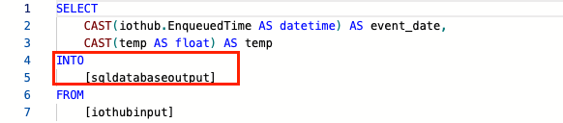

**Step 11.** Turn on your Raspberry Pi. Download ‘week5.py’ from the folder. Use Thonny to open it and complete the tasks, then save it. Open a terminal, direct to the desktop and run the script using ‘python week5.py’. You should see the output like the following. If the read is ‘-1’, reboot Raspberry Pi. Keep the script running.

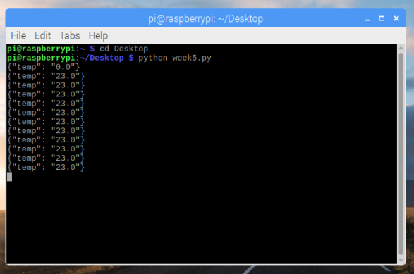

**Step 12.** Back to Azure Stream Analytics job. Click ‘Overview’ from the navigation menu, then click ‘Start’ and ‘Start’. It should take a while. When it finishes, a notification will prompt.



**Step 13.** Let it run for several minutes. Now you may wonder how to check the data generated in the table. Go back to the SQL database tab (if you closed it, click on ‘Home’ from the main navigation menu, you will find the SQL database from the ‘recent resource’ section). In the left navigation menu for the database, find and choose ‘Query editor(preview)’. Put in the password to login the SQL database. Then click ‘OK’.

**Step 14.** You will see a blank section called ‘Query 1’. Type the following SQL command in the query window, then click ‘Run’.



**Step 15.** If everything works, you should see the following in the ‘Results’ section below the query window. If nothing shows up, go back to Raspberry Pi, use ‘ctrl+c’(control + c on Mac) to terminate the script then run it again. After that, Stop the Stream Analytics job and restart it again.



**Step 16.** Since we did not provide data for Humidity and sound, they won’t show up in the table. Now go back to the python script ‘week6.py’ on your Raspberry Pi. Try to finish **Task 2**. You only need to add a bit code on line 80 to send humidity data. Use the link on line 77 as a reference to study JSON format, and make the script send humidity data to Azure SQL database.

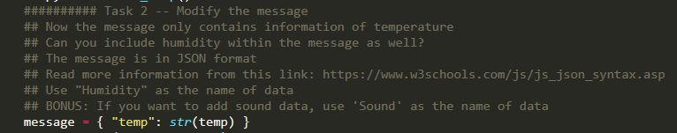

**Step 17.** In the comment of the script, you may notice there are some ‘BONUS’s. In week 3, we were able to send temperature, humidity, and sound level data to local MariaDB on Raspberry Pi. Our Azure SQL database was set up to receive sound level data as well. Revisited the ‘week3_partB.py’. Then connect the sound sensor to the GrovePi and modify the python script to make it send sound level data to Azure SQL database.

**Hints: 1.** Connect the sound sensor to Port A2

**2.** Declare the sound sensor at line 13 in the python script.

**3.** Modify read_temp() method and line 72; modify the ‘message’ at line 80

**4.** Modify the Query in Stream Analytics job on Azure, make sure you map the name right. Ex. Humidity and sound. Make them all floating value. The following image is an example.

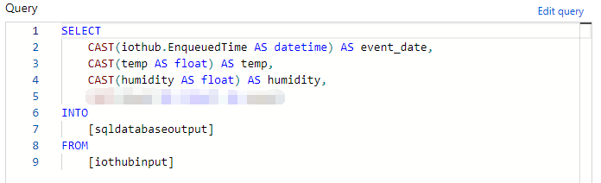

**5.** Make sure you test your query before you save it. If you forget how to test it, go back to week 5 and check **Step 12** to **Step 14**.

**6.** There might be a chance that your database did not receive any data from the IoT hub. To solve that, delete the previous database in Azure SQL database by typing ‘**DROP TABLE Temp_Hum_Sound;**’ in the query window of Query editor. Use the SQL commands in **Step 6** to re-create the database.

**7.** Keep the python script running before you start the Stream Analytics.

**8.** Let it run for several minutes. Use SQL command in **Step 14** to check the database. If you experience any issues, use ‘ctrl+c’ to terminate the python script and stop the Stream Analytics job. Then reboot the Raspberry Pi, use terminal to run the script again, then re-create the database and restart the Stream Analytics job again.

Congratulations! This is the end of Lab 5. Next week, we are going to learn more Azure service like Azure ML and do comparison between different visualization tools like PowerBI and Tableau. Furthermore, there is an upcoming final project and the idea will be mentioned in the last part of next week. Keep up the good work!

**Reference**

1. <https://docs.microsoft.com/en-us/azure/iot-hub/iot-hub-live-data-visualization-in-power-bi>

2. <https://gunnarpeipman.com/iot/beer-iot-stream-analytics-sql/>

3.